What Could Make That Function?
Name _____________________________________ Date ____________ Period ___________
Task 1: How is the Weather?
Given below are three graphs that show solar radiation, S, in watts per square meter, as a function of time, t, in hours since midnight. We can think about this quantity as the maximum amount of power that a solar panel can absorb, which tells us how intense the sunshine is at any given time.
Match each graph to the corresponding description of the weather during the day. (Note the scales are not consistent for the three graphs).
a. It was a beautifully sunny day from sunrise to sunset – not a cloud in the sky.
b. The day started off foggy but eventually the fog lifted and it was sunny the rest of the day.
c. It was a pretty gloomy day. The morning fog never really lifted.
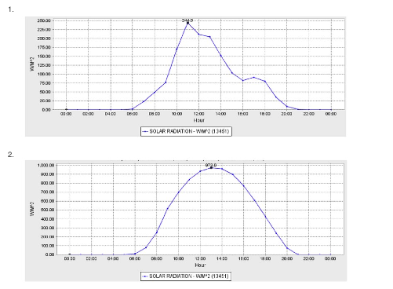

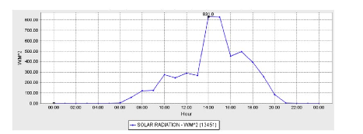
3.

Analysis Questions
1. Does each of the graphs represent a function? Why or why not?

2. What is f(12) for each of the graphs? What does this mean for each graph.

3. All three graphs show solar radiation measured in Santa Rosa, a city in Northern California. What other information can you get from the graph?

Task 2: What Could Make That Function?
What follows are pairs of graphs and stories that could explain what that function might represent. If a story is given, sketch the graph to represent the function the scenario describes. If a graph is given, create a story to explain data that could have made that graph. For each pair, list the key features of the graph using the words from the box below. Make sure to include labels for the axes.
Vocabulary words to Describe Functions:
Maximum Minimum Linear Function Non-Linear Function
Range Domain Symmetry End Behavior
Increasing over the interval of ______ Decreasing over the interval of _____

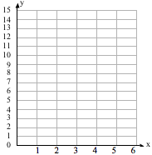
1.
Story:

Dax was at the beach watching the waves roll in. He was looking at the height of the water as time passed.

Key Features of the Graph:
_____________________________________________________________________

_____________________________________________________________________

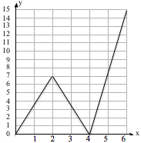
2.
Key Features of the Graph:
_____________________________________________________________________

_____________________________________________________________________
Story:

_____________________________________________

_____________________________________________

_____________________________________________

_____________________________________________

_____________________________________________

_____________________________________________

3.
Key Features of the Graph:
_____________________________________________________________________

_____________________________________________________________________
Story:

Kayla lit a candle at home and watched as the height of the candle decreased as time passed. A few minutes after she lit the candle, she extinguished the flame only to light the candle again two minutes later.

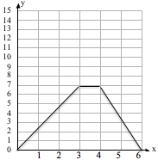
4.
Story:

_____________________________________________

_____________________________________________

_____________________________________________

_____________________________________________

Key Features of the Graph:
_______________________________________

________________________________________

5.
Story:

For the past five years, Isaac has grown two inches every year. This year he grew four inches.

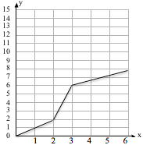
6.
Key Features of the Graph:
_______________________________________

_______________________________________
Story:

_____________________________________________

_____________________________________________

_____________________________________________

_____________________________________________

Teacher Directions
Materials:
Optional: Mini-Whiteboards, pens and erasers for each student.

Objective:
Students will analyze graphs in context of given scenarios involving solar radiation and then everyday contexts to interpret the meaning of the graph and describe the function and graph.

Directions: Note: Weather Problem from Illustrative Mathematics
Pass out the activity sheet. Have a student read the opening scenario aloud. Give students 5 minutes to work alone to match the three graphs to the scenarios (and to answer the analysis questions if finished early). Then have students share their thinking with a partner for 3 minutes. Use random selection to have students share which graph they matched with which scenario and why.

Task 2: What could make that function
In this task, students will either create a story to match a graph or draw a graph to represent the data described in a story. Make sure students label the axes, encouraging them to consider what might be dependent upon some other variable. Students will also apply their academic language to describe key features of the graph. Option #1- go through each pair of story and graph one at a time, having students record their graph or story on a mini-white board and holding them up to share after 2-3 minutes to think and work. Call on a few students to share their graph or story with the class. Option #2- Have students or pairs complete all 6 pairs of stories and graphs and then use inside-outside line to have students share each one. Do two rotations for EACH scenario (so a total of 12 rotations).

